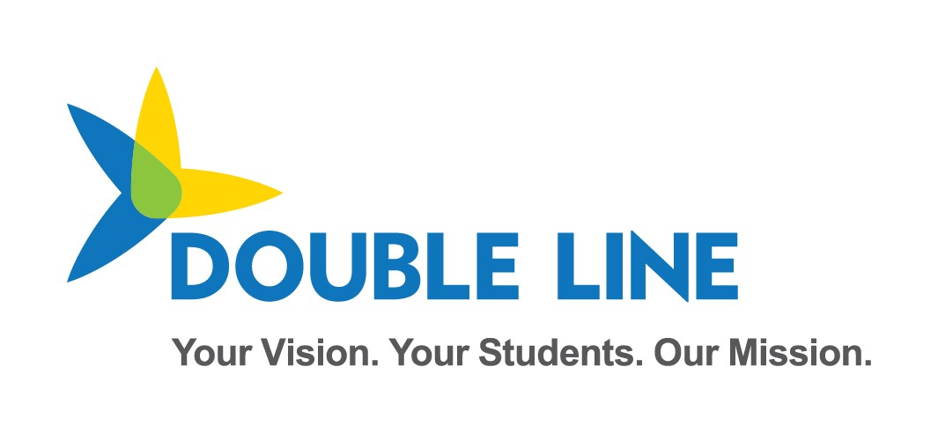

SIS Vendor and District Test Plan for School Year 2020-2021 (Ed-Fi 3.1)

Minnesota Department of Education & Minnesota IT Services Automated Student Data Collection System

Revision date: 04/21/2020

Table of Contents

Overview 1

MN Sandbox Certification Testing 1

Test Sandbox Environment URLs: 2

Sandbox Environment Helpful Tips 4

How LocalEducationAgencyId and SchoolId are derived from MDE stateOrganizationID 4

2020-2021 Data Requirements - API Resources 6

API Documentation 6

Mapping Documentation 8

School Year 20-21 Collection Updates Summary 9

Education Organization Id usage by Resource 9

2020-2021 SIS Submitted MDE Ed-Fi API Resources – MARSS Data Collection 9

Resource: Students 9

Resource: StudentSchoolAssociations 10

Resource: StudentEducationOrganizationAssociation 11

Resource: Calendar 12

Resource: Programs 12

StudentProgramAssociations 13

Resource: Student21stCenturyLearningCenterGrantProgramAssociation 13

Resource: StudentCEISProgramAssociation 13

Resource: StudentEarlyChildhoodScreeningProgramAssociations 13

Resource: StudentGiftedTalentedProgramAssociation 14

Resource: StudentADSISProgramAssociation 14

Resource: StudentHomelessProgramAssociation 14

Resource: StudentLanguageInstructionProgramAssociation 15

Resource: StudentPSEOConcurrentProgramAssociation 15

Resource: StudentPSEOProgramAssociation 15

Resource: StudentSAAPProgramAssociation 16

Resource: StudentSchoolFoodServiceProgramAssociation 16

Resource: StudentSection504PlanProgramAssociation 16

Resource: StudentSpecialEducationProgramAssociation 17

Resource: StudentTitleIPartAProgramAssociations 17

2020-2021 Early Education Enrollment Certification Scenarios - API Resources 18

Resource: StudentSchoolAssociations 18

Resource: Parent 19

Resource: StudentParentAssociation 19

Resource: StudentEducationOrganizationAssociation 20

Resource: StudentEarlyEducationProgramAssociations 20

Resource: StudentHomelessProgramAssociation 21

Resource: StudentLanguageInstructionProgramAssociation 21

2020-2021 MDE Submitted Data Requirements - API Resources 22

Resource: LocalEducationAgencies 22

Resource: Schools 22

Resource: Program 22

Ed-Fi Model Dependency Graph (MARSS collection) 24

Ed-Fi Model Dependency Graph (Early Education Enrollment and Parent collection) 25

Staging Environment Load and Quality Check 26

Ed-Fi Identities API Integration Test 26

Create Student ID Test 1 27

Create Student ID Test 2 27

Ed-Fi Student Record Validation Test 28

Student Validation Process Overview 28

Validate Student ID Test 1 29

Validate Student ID Test 2 29

**Change Log:**

|  |  |  |
| --- | --- | --- |
| **Version** | **Date** | **Description of Changes** |
| v1.0 | 03/30/2020 | Updated for SY20-21 |
| V1.1 | 04/21/2020 | Corrected URLs and fixed typo |
| V1.2 | 05/13/2020 | Updated Swagger Screenshot |

# Overview

Student Information Systems vendors integrating with the Minnesota Department of Education's (MDE) Ed-Fi Automated Student Data Collection system are required to pass 2 levels of testing prior to being granted a district's API key and secret to the production environment.

The 20-21 School Year Certification is currently aligned with Ed-Fi 3.1 Data Standard and ODS/API with extensions customized for MDE.

First, vendors are required to demonstrate their ability to submit the specific API resources and elements encompassed within the MARSS and Early Education Enrollment Data elements. This first phase is executed in the MNIT Ed-Fi Test Sandbox environment.

**The Test Sandbox environment does not include integration with the Identities API endpoint.**

**API profiles are not enforced in the Test Sandbox environment, however you may be required to demonstrate appropriate implementation of API profile use in your api transactions.**

When all scenarios are verified in the Sandbox testing environment, the SIS vendor is granted access to the Staging Environment. Vendors must perform a test load of their district's real student demographic data in the Staging environment. During this test Student IDs will be validated against the Ed-Fi Identities Service to ensure valid ids are being inserted to the Ed-Fi ODS. MARSS comparison checks and additional data quality verifications are executed in the Staging Environment.

Once the Staging data reaches a satisfactory level of quality as determined by MDE, MNIT, and the District, MNIT will enable the vendor to obtain a key and secret for the production environment.

This document includes the Certification Requirements for both the scenario-based sandbox testing and staging environment data loading.

# MN Sandbox Certification Testing

When certification begins, vendors will be provided a key and secret to a sandbox ODS/API with no sample data pre-loaded. This ODS will contain the Minnesota Education School and District records synchronized with MDE-ORG, as well as the MN specific descriptors listed below in this document. When submitting data for each of the Certification scenarios, we ask that you use a district you have access to, and schools within the district.

## Test Sandbox Environment URLs:

**Swagger:**

<https://test.edfi.education.mn.gov/sb20_/EdFi.Ods.SwaggerUI/>

* All MN Specific resources defined for the 19-20 School Collection can be found under the Profile: Minnesota-SISVendor-Profile.
* All MN Specific resources defined for the 20-21 School Collection can be found under the Profile: Minnesota-Twenty-Twenty-One-SISVendor-Profile.
* All MN Specific resources defined for the 20-21 School Collection can be found under the Profile: Minnesota-Twenty-Twenty-Two-Preview-SISVendor-Profile.

*Note: The Identities Section is provided as documentation only – and is not functional in the Sandbox environment*

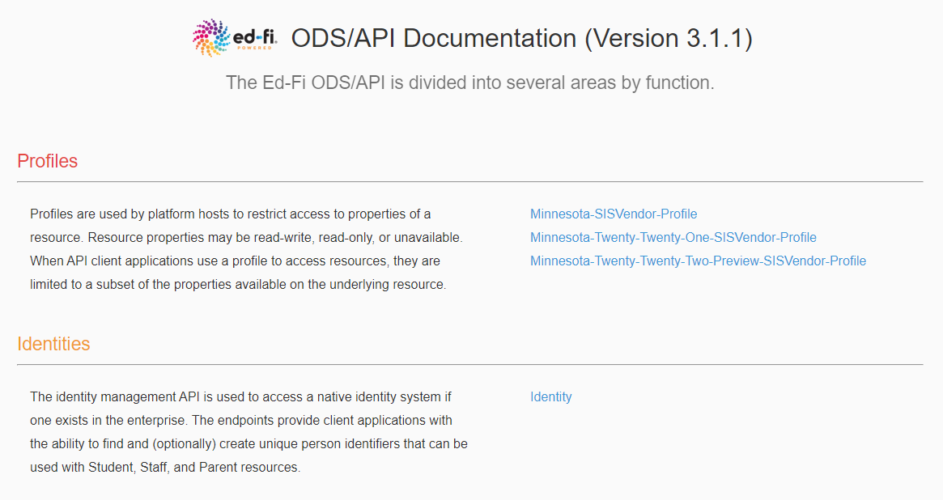

**Ed-Fi Sandbox Admin Website**

<https://test.edfi.education.mn.gov/sb20_/EdFi.Ods.Admin.Web>/

To request an account please contact MDE.

In the Sandbox Admin Tool, you will create test sandbox ODS instances to use for development and testing of your integrations.

**ODS/API base URL**

<https://test.edfi.education.mn.gov/sb20_/edfi.ods.webapi/data/v3/>

**URL changes for addressing extension vs core resources**

**Extensions**

The URL for addressing MN extension resources should include ‘mn’ after v3, for example:

When addressing studentSection504PlanProgramAssociations, a Minnesota Dept of Education extension entity, the URL is:

…/edfi.ods.webapi/data/v3/**MN**/studentSection504PlanProgramAssociations

**Core**

The URL for addressing core resources should include ‘ed-fi’ after v3, for example:

When addressing StudentSchoolAssociation, a core ed-fi entity, the URL is:

…/edfi.ods.webapi/data/v3/**ed-fi**/StudentSchoolAssociation

**Important Note**: the school year must be included after “/v3/” and before the core/extension namespace in QA, Stage and Production, **but not in Sandbox.**

For example:

…/edfi.ods.webapi/data/v3/**2021**/ed-fi/StudentSchoolAssociation

…/edfi.ods.webapi/data/v3/**2021**/MN/studentSection504PlanProgramAssociations

**ODS/API oauth URL**

<https://test.edfi.education.mn.gov/sb20_/edfi.ods.webapi/oauth/>

Authentication In Ed-Fi 3.x ODS/API has been updated to use two-legged OAuth 2.0 Client Credentials Grant Flow. More information and sample API calls are located here:

<https://techdocs.ed-fi.org/display/ODSAPI32/Authentication>

## Sandbox Environment Helpful Tips

* Swagger In the staging and production environments, SIS vendor API keys will be associated with a claim set limiting access to only the API resources included in this document. This claim set has been enabled in the Sandbox environment. When you access a resource not included in the claim set you will receive the following message in the response "Access to the resource could not be authorized. Are you missing a claim?”
* A SIS Vendor profile has been created limiting access to specific properties on each of the resources required in School Year 19-20. This is available in the API section: “Profile: Minnesota-SISVendor-Profile”
  + This profile will be auto-enabled in Staging and Production – meaning you will not have to include the profile in the “accept” or “content-type” headers of the request for the profile to take effect.
* When creating a sandbox, you have the option of including a set of sample data in the sandbox. The sample data used, is associated with St. Paul Public School District (LocalEducationAgencyId = 10625000). When you do not select the option to include sample data, your sandbox database will be loaded with an essentially empty ODS except that it will include MN Schools and Districts, and the Descriptors that MDE has customized for this implementation for School Year 19-20.
* The actual certification test will be conducted in a sandbox with no sample data loaded and you will reference your own MDE Schools, Districts and Descriptors in the Scenarios.
* The Sandbox Environment ignores the School Year included in the API base URL. Since you will be submitting data to the 2019-2020 School year, to prep for submissions to Staging and Production your testing should include the year 2020.
* MN custom descriptor codes have been loaded under the namespace "uri://education.mn.gov/”
* Assessment specific descriptors for the MCA/MTAS and Access/Access-ALT assessments have been namespaced as follows with a reference to the assessment in the namespace
  + uri://education.mn.gov/mcamtas/assessmentReportingMethodDescriptor
  + uri://education.mn.gov/access/assessmentReportingMethodDescriptor
* All Descriptor references now require namespaces, and do not rely on the concept of a default operational context. Descriptor references must be formatted as follows: uri://[organization indicator]/[name of descriptor]#[code value]

For example: **uri://education.mn.gov/ProgramTypeDescriptor#Special Education**

* The School Ids and District Ids used for the ODS/API resources are the MN State Education Organization IDs.

## How LocalEducationAgencyId and SchoolId are derived from MDE stateOrganizationID

The MDE stateOrganizationID is formatted as follows: ttddddsssmmm

Where:

* tt = district type
* dddd = district number, left zero filled
* sss = school number, left zero filled, 000 for districts
* mmm = 000 for all organizations reported in Ed-Fi

The MDE stateOrganizationID value is stored in Ed-Fi on the Ed-Fi **EducationOrganizationIdentificationCodes** collection and is surfaced via the Ed-Fi **LocalEducationAgencies** and **Schools** Resource endpoints.

The Ed-Fi LocalEducationAgencyId and SchoolId are derived as follows ttddddsss. ‘sss’ is Zero filled for the LocalEducationAgencyId.

For Example:

MN State Organization ID for a school is 10535315000 – Ed-Fi SchoolId = 10535315

MN State Organization ID for a district is 10535000000 – Ed-Fi LocalEducationAgencyId = 10535000

# 2020-2021 Data Requirements - API Resources

## API Documentation

For each of the following resources, the elements/properties required for the MN 19-20 collection are included in Swagger under the Minnesota-SISVendor-Profile:

[https://test.edfi.education.mn.gov/sb20_/EdFi.Ods.SwaggerUI/](https://test.edfi.education.mn.gov/SB20_/EdFi.Ods.SwaggerUI/)

For example, to view required resource properties for StudentSchoolAssociation, open the post action in Swagger:

example of post action in Swagger

Note: ed-fi in the path above indicates that this is a core resource.

Properties in the StudentSchoolAssociation can be viewed as the JSON object sample by selecting “Example Value”:

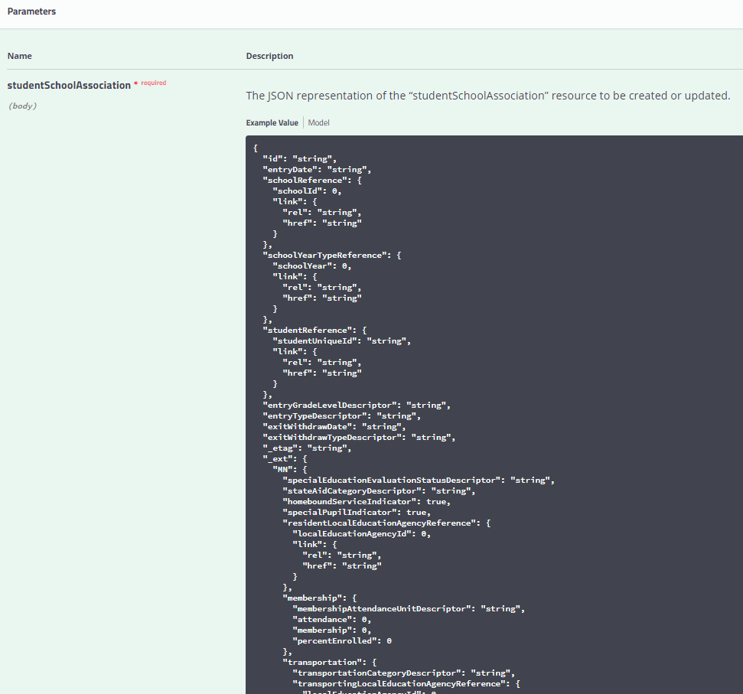

Definitions and Data Types in the StudentSchoolAssociation can be viewed by selecting “Model”:

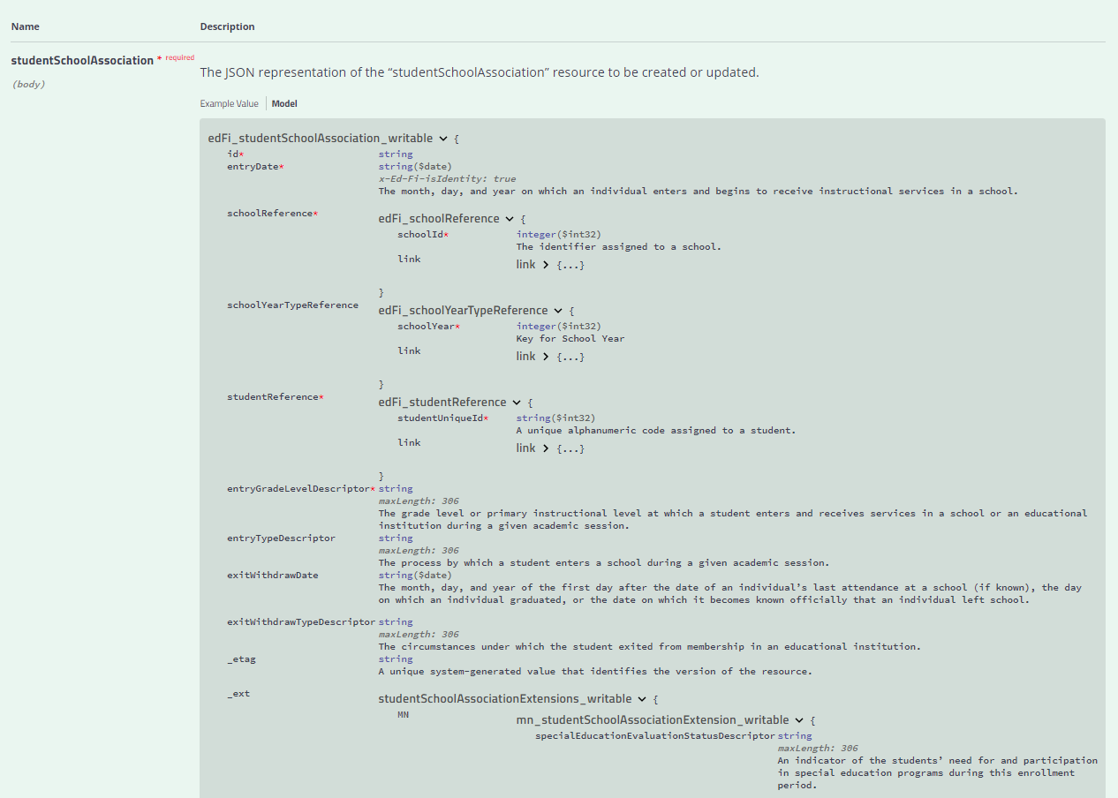

## Mapping Documentation

School Year 20-21 will introduce the Ed-Fi collection of Minnesota Common Course Catalogue (MCCC) and Graduation Requirements (GRR). MCCC will not implement any of the Early Childhood elements at this time.

In addition, MDE is beginning to work toward the eventual collection of Assessment pre-code and Assessment results data for the MCA and MTAS Assessment.

In School Year 19-20, MDE implemented an Ed-Fi based MARSS collection.

For context around how each MDE collection maps to the Ed-Fi Data Standard please view the following spreadsheets:

[MARSS 2019-2020 Mapping Review Matrix Ed-Fi 3.1.xls spreadsheet](https://education.mn.gov/mdeprod/idcplg?IdcService=GET_FILE&dDocName=MDE086562&RevisionSelectionMethod=latestReleased&Rendition=primary) (MARSS)

MCCC Mapping Matrix <link>

GRR Mapping Matrix <link>

Mapping Matrix MN Assessment Pre-code to Ed-Fi 3.1 <link> (MCA/MTAS Precode and Assessment Results)

The Mapping Review Matrix documents include the mappings between MDE elements and Ed-Fi core and extension entities and elements.

Additionally, the Descriptor values applicable to each Collection are also included in these documents for reference.

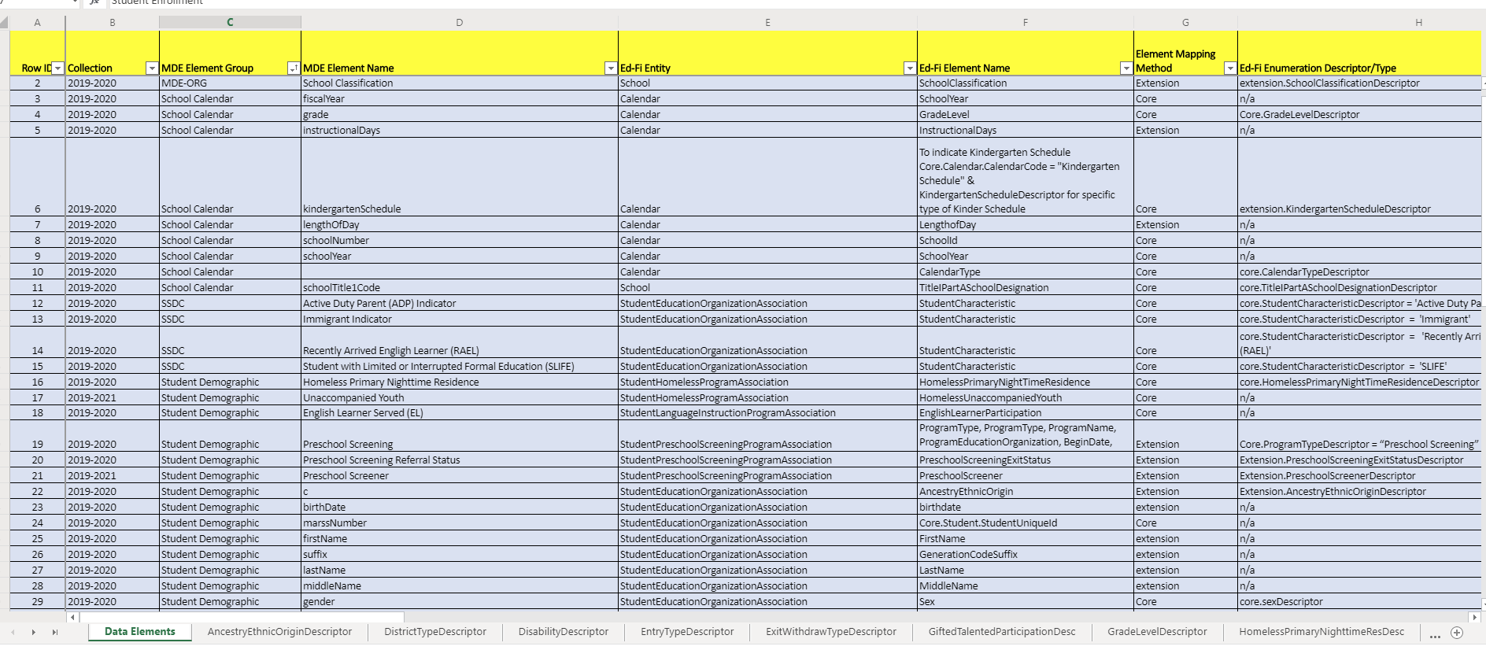

**Data Element Mappings** **Descriptors**

## School Year 20-21 Collection Updates Summary

School Year 20-21 will continue collection of MARSS and Ancestry of Ethnic Origin data via Ed-Fi. In addition, MDE will begin collecting Early Education Enrollment along with Early Education Parent data.

* EE Enrollment includes:
  + StudentSchoolAssociation
  + StudentEducationOrganizationAssociation
  + StudentEarlyEducationProgramAssociation
* EE Parent includes:
  + Parent
  + StudentParentAssociation

**IMPORTANT NOTE:** The API for MDE’s MCCC, GRR, and MCA/MTAS Assessments has been developed and made available in the 3.1 codebase and in the School Year 20-21 sandbox environment, however integration with the endpoints encompassed in these domains will not be rolled out to districts until 2021-2022.

The inclusion of these API resources at this early stage is intended to assist vendors with the work required to integrate your application with these collections and begin planning your development effort. With this early release we hope that you will have the ability to plan for the size of the project and plan accordingly.

Ed-Fi MCCC will start with the 2021-22 data collection based on the current schedule. Additional details coming soon include a mapping of the current data collection to the Ed-Fi standard and details on validations added to EDVP that had been previously done via XML. Timelines for GRR and Assessments via Ed-Fi are to be determined.

## Education Organization Id usage by Resource

Education Organization References in the Ed-Fi API allow an API client to submit either a Local Education Agency,School Id, PostSecondaryInstitutionId however the MDE implementation requires that the following ids must be used for Education Organization References.

| **Resource** | **Element** | **ID** |
| --- | --- | --- |
| StudentEducationOrganizationAssociation | educationOrganizationReference.educationOrganizationId | School Id |
| StudentProgramAssociation (all program types) | educationOrganizationReference. educationOrganizationId | School Id |
| StudentProgramAssociation (all program types) | programReference.educationOrganizationId | Local Education Agency Id |

## 2020-2021 SIS Submitted MDE Ed-Fi API Resources – MARSS Data Collection

### Resource: Students

**Description**

This entity represents an individual for whom instruction, services, and/or care are provided in an early childhood, elementary, or secondary educational program under the jurisdiction of a school, education agency or other institution or program. A student is a person who has been enrolled in a school or other educational institution.

**Prerequisite Data**

* None

**Certification Scenarios**

1. Create 14 student records including the following elements.
   1. studentUniqueID
   2. birthdate
   3. birthSexDescriptor
   4. firstName
   5. generationCodeSuffix
   6. lastSurname
   7. middleName

### Resource: StudentSchoolAssociations

**Description**

This association represents the School in which a student is enrolled. The semantics of enrollment may differ slightly by state. Non-enrollment relationships between a student and an education organization may be described using the StudentEducationOrganizationAssociation.

**Prerequisite Data**

* Students
* Schools

**Certification Scenarios**

1. Enroll student 1 at Elementary School, including
   1. homeboundServiceIndicator
   2. specialPupilIndicator
2. Enroll student 2 at Middle School.
3. Withdraw student from Middle School.
4. Enroll student 2 at High School.
5. Create the following records for Student 2
   1. An enrollment
   2. Withdrawal
   3. Re-enrollment of a student who changes resident districts but does not change schools. Place a 20 day gap between records.
6. Update Student 1’s Percent Enrolled to 50% and set membershipAttendanceUnitDescriptor to days, set membership and attendance.
7. Update Student **1’s Percent Enrolled to 100%** membershipAttendanceUnitDescriptor to hours and adjust membership and attendance accordingly.
8. Update Student 2’s Transportation Category.
9. Update Student 3’s StateAid Category.
10. Create 2 enrollment records (a, b) for a student that is in two different schools within the same district at the same time. Enrollment dates 09/10/17 through 06/10/18.
11. Create the records for
    1. An enrollment,
    2. Withdrawal and
    3. Re-enrollment for a kindergarten student who receives an IEP mid-year – send updated special education evaluation status. (Grade change from KA to HK, and specialEducationEvaluationStatus updated)

### Resource: StudentEducationOrganizationAssociation

**Description**

This association indicates any relationship between a student and an education organization other than how the state views enrollment. Enrollment relationship semantics are covered by StudentSchoolAssociation.

MDE allows for the capture of student demographic data by school enrollment. Therefore, a StudentEducationOrganizationAssociation record must be submitted for each **school** in which the student is enrolled to provide the student demographic data provided to the enrolling school by the parent(s).

**Prerequisite Data**

* Students
* EducationOrganizations (Schools)

**Scenarios**

1. Create a StudentEducationOrganizationAssociation between Student 1 and an Elementary School, Include the following data points:
   1. EthnicCode by sending a StudentCharacteristic = ‘American Indian - Alaskan Native (Minnesota)’
   2. Race = ‘American Indian - Alaska Native’
   3. Birthdate
   4. sexDescriptor
   5. firstName, middleName, lastName, generationCodeSuffix
   6. hispanicLatinoEthnicity
   7. languageDescriptor
   8. languageUseDescriptor = ‘Home Language’
   9. studentIdentificationCodes
   10. studentIdentificationSystemDescriptor = ‘Local’
   11. assigningOrganizationIdentificationCode = ‘District Id’
   12. identificationCode = local use code
2. Update Student 1’s record to include Ancestry of Ethnic Origin = ai-cherokee
3. Update Student 1’s record to include a second Ancestry of Ethnic Origin = as-burmese
4. Create a StudentEducationOrganizationAssociation between Student 2 and Middle School.
5. Create a StudentEducationOrganizationAssociation between Student 2 and High School.
6. Update Student 3’s OptOutIndicator

### Resource: Calendar

**Description**

Ed-Fi Description: A set of dates associated with an organization. MDE is not using the Calendar entity as collection of dates, rather MDE captures the following key pieces of Calendar Metadata in the Calendar file: Instructional Days, Length of Day, and Kindergarten Schedule (when applicable). Calendar is captured at the School Level by grade.

**Prerequisite Data**

* Schools (published to ODS by MDE)

**Changes from 19-20 to 20-21**

New properties:

* DaysInSession
* Description
* New CalendarTypeDescriptor for MCCC

**Scenarios**

**MARSS**

1. Create calendar record for Elementary School grades 1 through 5 (do not include kindergarten as grade level)
   1. Length of day = 360
   2. Instructional Days = 167
2. Update calendar created in scenario one by reducing the Instructional Days from 167 to 166
3. Create calendar record for Elementary School for Kindergarten only - use grade KG
   1. Length of day = 360
   2. Instructional Days = 165
4. Create Full Year School Readiness Plus calendar for Elementary School grade RA
   1. Length of day = 150
   2. Instructional Days = 148
5. Create Half Year School Readiness Plus calendar for Elementary School grade RB
   1. Length of day = 150
   2. Instructional Days = 78
6. Create Middle School Calendar
7. Create High School Calendar

### Resource: Programs

**Program Records for each of the following program types will be loaded for each district by MDE**

The educationOrganizationReference for the StudentProgramAssociation is the **SchoolId**.

The educationOrganizationReference on the StudentProgramAssociation’s programReference is the **LocalEducationAgencyId**.

## StudentProgramAssociations

### Resource: Student21stCenturyLearningCenterGrantProgramAssociation

**Description**

This association represents Students in the 21st Century Community Learning Centers Grant Program.

**Prerequisite Data**

* Schools
* Program - where ProgramTypeDescriptor = “21st Century Learning Center Grant”
* Students

**Scenarios**

* Associate Student 1 with this StudentProgramAssociation

### Resource: StudentCEISProgramAssociation

**Description**

This association represents Students in the Coordinated Early Intervening Service Program.

**Prerequisite Data**

* Schools
* Program - where ProgramTypeDescriptor = “Coordinated Early Intervening Services”
* Students

**Scenarios**

* Associate Student 2 with this StudentProgramAssociation
* Delete this Student Program Association
* Delete Student 2’s Middle School StudentEducationOrganizationAssociation record.
* Delete student 2’s Middle School enrollment record.

### Resource: StudentEarlyChildhoodScreeningProgramAssociations

**Description**

This association represents Students in the Early Childhood Screening Association Program.

**Prerequisite Data**

* Schools
* Program - where ProgramTypeDescriptor = “Early Childhood Screening”
* Students

**Scenarios**

1. Associate Student 3 with this StudentProgramAssociation
2. Change the earlyChildhoodScreenerDescriptor to ‘Head Start’ and earlyChildhoodScreeningExitStatusDescriptor to ‘Rescreen’

### Resource: StudentGiftedTalentedProgramAssociation

**Description**

This association represents Students in the Gifted Talented Program.

**Prerequisite Data**

* Schools
* Program - where ProgramTypeDescriptor = “Gifted and Talented”
* Students

**Scenarios**

1. Associate Student 4 with this StudentProgramAssociation
2. Change the gifted talented participation code to ‘Full-time services’

### Resource: StudentADSISProgramAssociation

**Description**

This association represents Students in the Alternative Delivery of Specialized Instruction (ADSIS) Program.

**Prerequisite Data**

* Schools
* Program - where ProgramTypeDescriptor = “Alternative Delivery Of SIS”
* Students

**Scenarios**

1. Associate Student 5 with this StudentProgramAssociation

### Resource: StudentHomelessProgramAssociation

**Description**

This association represents the McKinney-Vento Homeless Program program(s) that a student participates in or from which the Student receives services.

**Prerequisite Data**

* Schools
* Program - where ProgramTypeDescriptor = “Homeless”
* Students

**Scenarios**

1. Associate Student 6 with this StudentProgramAssociation
2. Change the primary nighttime residence code to ‘Doubled-Up’ and Unaccompanied Youth to True
3. Submit a StudentHomelessProgramAssociation for the EE enrolled student
   1. Primary Nighttime Residence = SHR
   2. Begin Date 9/5/2019
   3. End Date 12/25/2020

### Resource: StudentLanguageInstructionProgramAssociation

**Description**

This association represents the Title III Language Instruction for Limited English Proficient and Immigrant Students program(s) that a student participates in or from which the Student receives services.

**Prerequisite Data**

* Schools
* Program - where ProgramTypeDescriptor = “English Learner”
* Students

**Scenarios**

1. Associate Student 7 with this StudentProgramAssociation where English Learner Participation is set to True (Indicates EL Served)
2. Change the English Learner Participation to False, to Indicate EL Identified, but not served
3. Associate another student with this program and set the language service code to ‘Newcomer Program’

### Resource: StudentPSEOConcurrentProgramAssociation

**Description**

This association represents Students in the PSEO Concurrent Enrollment Program.

**Prerequisite Data**

* Schools
* Program - where ProgramTypeDescriptor = “PSEO Concurrent”
* Students

**Scenarios**

1. Associate Student 8 with this StudentProgramAssociation

### Resource: StudentPSEOProgramAssociation

**Description**

This association represents Students in the PSEO Program.

**Prerequisite Data**

* Schools
* Program - where ProgramTypeDescriptor = “PSEO Program”
* Students

**Scenarios**

1. Update PSEO High School Hours to 650
2. Associate Student 9 with this StudentProgramAssociation

### Resource: StudentSAAPProgramAssociation

**Description**

This association represents Students in a State Approved Alternative Program.

**Prerequisite Data**

* Schools
* Program - where ProgramTypeDescriptor = “SAAP”
* Students

**Scenarios**

1. Associate Student 10 with this StudentProgramAssociation
2. Change SAAP Credits to 5.75 and Set Independent Study indicator to True and SAAP concurrent indicator to Yes

### Resource: StudentSchoolFoodServiceProgramAssociation

**Description**

This association represents the school food services program(s), such as the Free or Reduced Lunch Program, that a student participates in or from which the Student receives services.

Note: in School Year 18-19 schoolFoodServicesEligibility was tracked as a separate field under StudentSchoolAssociation. This element is now tracked using SchoolFoodServiceProgramService on studentSchoolFoodServicesProgramAssociation.

**Prerequisite Data**

* Schools
* Program - where ProgramTypeDescriptor = “School Food Service”
* Students

**Scenarios**

1. Associate Student 11 with this StudentProgramAssociation with SchoolFoodServiceProgramService = 2
2. Change FRP Meal Code to 1

### Resource: StudentSection504PlanProgramAssociation

**Description**

Students who have a Section 504 plan.

**Prerequisite Data**

* Schools
* Program - where ProgramTypeDescriptor = “Section 504 Plan”
* Students

**Scenarios**

1. Associate Student 12 with this StudentProgramAssociation

### Resource: StudentSpecialEducationProgramAssociation

**Description**

This association represents the special education program(s) that a student participates in or receives services from. The association is an extension of the StudentProgramAssociation particular for special education programs.

**Important Notes on Order of Disability**

MDE collects the primary disability code for a student during an enrollment period.

* Disability codes must be reported to Ed-Fi with the 'order of disability' as 1 to designate the primary disability.
* Although additional disability codes for a student might be reported for a particular begin date, they will be ignored by MDE and not collected or stored in the MDE transformations. In other words, only the disability code with ‘order of disability’ 1 will be used for any begin date.
* If multiple disability codes for a student are reported with the same begin date, there must only be one with an order of disability = 1.

**Prerequisite Data**

* Schools
* Program - where ProgramTypeDescriptor = “Special Education”
* Students

**Scenarios**

1. Associate Student 13 with this StudentProgramAssociation include a disability with order of priority = 1
2. Change disability code to 12, set special education service hours to 1100.5

### Resource: StudentTitleIPartAProgramAssociations

**Description**

This association represents the Title I Part A program(s) that a student participates in or from which the Student receives services. The association is an extension of the StudentProgramAssociation particular for Title I Part A programs.

**Prerequisite Data**

* Schools
* Program - where ProgramTypeDescriptor = “Title I Part A”
* Students

**Scenarios**

1. Associate Student 14 with this StudentProgramAssociation

## 2020-2021 Early Education Enrollment Certification Scenarios - API Resources

### Resource: StudentSchoolAssociations

**Description**

This association represents the School in which a student is enrolled. The semantics of enrollment may differ slightly by state. Non-enrollment relationships between a student and an education organization may be described using the StudentEducationOrganizationAssociation.

**Prerequisite Data**

* Students
* Schools

**Certification Scenarios**

1. Submit an Early Education Enrollment record (StudentSchoolAssociation with entrygradelevel = EE)
   1. Required elements
      1. School Id
      2. Student Unique Id
      3. Entry Grade Level = EE
      4. Entry Type (Last Location Code) = 0
      5. Entry Date = 9/5/2020
      6. Exit Withdraw Date (Defaulted to end of school year)
      7. Exit Withdraw Type = 20
      8. Homebound Service Indicator = N
      9. Resident Local Education Agency
      10. Special Pupil Indicator = N
   2. Data **not** collected for Early Education
      1. State Aid Category
      2. Membership Attendance Units
      3. Membership Attendance Percent Enrolled
      4. Special Education Eval Status
      5. Transportation
2. Submit an Early Education Enrollment record (StudentSchoolAssociation with entrygradelevel = 1)
   * 1. School Id
     2. Student Unique Id
     3. Entry Grade Level = 1
     4. Entry Type (Last Location Code) = 4
     5. Entry Date = 9/6/2020
     6. Exit Withdraw Date (Defaulted to end of school year)
     7. Exit Withdraw Type = 40
     8. Homebound Service Indicator = N
     9. Resident Local Education Agency
     10. Special Pupil Indicator = N
3. Submit an Early Education Enrollment record (StudentSchoolAssociation with entrygradelevel = PA)
   * 1. School Id
     2. Student Unique Id
     3. Entry Grade Level = PA
     4. Entry Type (Last Location Code) = 4
     5. Entry Date = 9/6/2020
     6. Exit Withdraw Date (Defaulted to end of school year)
     7. Exit Withdraw Type = 40
     8. Homebound Service Indicator = N
     9. Resident Local Education Agency
     10. Special Pupil Indicator = N

### Resource: Parent

**Description**

This entity represents a parent or guardian of a student, such as mother, father, or caretaker.

**Prerequisite Data**

None

**Scenarios**

1. Submit Parent Records for the following Early Ed Student in Gradelevel EE
   * 1. Required Elements:
        1. Parent Unique Id
        2. firstName
        3. lastSurname
        4. MiddleName
        5. generationCodeSuffix
        6. highestCompletedLevelOfEducationDescriptor
        7. householdIncome
        8. householdSize
        9. receivingInterpreterAssistance
        10. classroomVolunteerDescriptor
        11. birthDate
        12. sexDescriptor
   1. Submit Parent Records for the following Early Ed Student in Gradelevel 1
   2. Submit Parent Records for the following Early Ed Student in Gradelevel PA

### Resource: StudentParentAssociation

**Description**

This association relates students to their parents, guardians, or caretakers.

**Prerequisite Data**

Students

Parents

StudentSchoolAssociations

**Scenarios**

1. Submit Student Parent Association Record for the Early Education Student in Gradelevel EE
2. Required Elements:
   * 1. Parent Unique Id
     2. Student Unique Id
     3. Relation Descriptor
3. Submit Student Parent Association Record for the Early Education Student in Gradelevel 1
4. Submit Student Parent Association Record for the Early Education Student in Gradelevel PA

### Resource: StudentEducationOrganizationAssociation

**Description**

This association indicates any relationship between a student and an education organization other than how the state views enrollment. Enrollment relationship semantics are covered by StudentSchoolAssociation.

MDE allows for the capture of student demographic data by school enrollment. Therefore, a StudentEducationOrganizationAssociation record must be submitted for each **school** in which the student is enrolled to provide the student demographic data provided to the enrolling school by the parent(s).

**Prerequisite Data**

* Students
* EducationOrganizations (Schools)

**Scenarios**

1. Create a StudentEducationOrganizationAssociation for the Student Enrolled in Gradelevel EE
   * 1. Include all elements except StudentCharacteristicsDescriptors (ADP, RAEL, IMMIGRANT, SLIFE)
2. Create a StudentEducationOrganizationAssociation for the Student Enrolled in Gradelevel 1
3. Create a StudentEducationOrganizationAssociation for the Student Enrolled in Gradelevel PA

### Resource: StudentEarlyEducationProgramAssociations

**Description**

This association represents Students in either School Readiness or Early Childhood Family Education programs.

**Prerequisite Data**

* Schools
* Program - where ProgramTypeDescriptor = “SR”
* Program - where ProgramTypeDescriptor = “ECFE”
* Students

**Scenarios**

1. Associate gradelevel EE Enrolled Student with this SR StudentEarlyEducationProgramAssociation
   1. Begin Date: 9/5/2020
   2. End Date: 6/11/2021 (default to last day in the school year)
   3. End Reason Code = PE-01
   4. Membership: 640
   5. Attendance: 580
   6. Submit funding sources PF and CC
2. Associate same gradelevel EE Enrolled Student with this ECFE StudentEarlyEducationProgramAssociation
   1. Begin Date = 9/5/2020
   2. End Date = 10/15/2020
   3. End Reason Code = PE-02
   4. Membership Hours = 40
   5. Attendance Hours = 30
   6. Submit funding sources PF, CC and TITLE
3. Associate gradelevel 1 Enrolled Student with an ECFE StudentEarlyEducationProgramAssociation
   1. Begin Date: 10/6/2020
   2. End Date: 6/11/2020 (default to last day in the school year)
   3. Membership: 640
   4. Attendance: 580
   5. Submit funding sources ECFE and CC
4. Associate gradelevel PA Enrolled Student with an SR StudentEarlyEducationProgramAssociation
   1. Begin Date: 9/7/2020
   2. End Date: 6/11/2020 (default to last day in the school year)
   3. Membership: 640
   4. Attendance: 580
   5. Submit funding sources CSPF and OD

### Resource: StudentHomelessProgramAssociation

**Description**

This association represents the McKinney-Vento Homeless Program program(s) that a student participates in or from which the Student receives services.

**Prerequisite Data**

* Schools
* Program - where ProgramTypeDescriptor = “Homeless”
* Students

**Scenarios**

1. Submit a StudentHomelessProgramAssociation for the EE enrolled student
   1. Primary Nighttime Residence = SHR
   2. Begin Date = 9/5/2019
   3. End Date = 12/25/2020

### Resource: StudentLanguageInstructionProgramAssociation

**Description**

This association represents the Title III Language Instruction for Limited English Proficient and Immigrant Students program(s) that a student participates in or from which the Student receives services.

**Prerequisite Data**

* Schools
* Program - where ProgramTypeDescriptor = “English Learner”
* Students

**Scenarios**

1. Submit StudentLanguageInstructionProgramAssociation for EE enrolled Student
   1. Begin Date = 9/5/2019
   2. End Date = 5/25/2021
   3. Lang Service Code = Transitional Bilingual
   4. EL Participation = 1

## 2020-2021 MDE Submitted Data Requirements - API Resources

### Resource: LocalEducationAgencies

**Description**

This entity represents an administrative unit at the local level which exists primarily to operate schools or to contract for educational services. It includes school districts, charter schools, charter management organizations, or other local administrative organizations.

**Prerequisite Data**

* None

Note: All required Local Education Agency data will be loaded by MDE

### Resource: Schools

**Description**

This entity represents an educational organization that includes staff and students who participate in classes and educational activity groups.

**Prerequisite Data**

* None

Note: All required School data will be loaded by MDE.

### Resource: Program

**Description**

Ed-Fi Description: This entity represents any program designed to work in conjunction with, or as a supplement to, the main academic program. Programs may provide instruction, training, services, or benefits through federal, state, or local agencies. Programs may also include organized extracurricular activities for students. MDE will create the following programs for each district with these program types:

* Section 504 Plan
* Title I Part A
* English Learner
* Gifted and Talented
* Special Education
* 21st Century Learning Center Grant
* Alternative Delivery Of SIS
* Coordinated Early Intervening Services
* Homeless
* PSEO Concurrent
* PSEO Program
* School Food Service
* Early Childhood Screening
* SAAP
* School Readiness
* Early Childhood Family Education

## Ed-Fi Model Dependency Graph (MARSS collection)

Descriptors

Calendar

Schools and LEAs

Student Records

Programs

StudentSchoolAssociation

(Enrollment Records)

Student Program Associations

StudentEducationOrganizationAssociation (Demographic Records)

1. Descriptors must be loaded first, as all other resources contain references to descriptor values.
2. Once descriptors are loaded, Education Organization data must be loaded by MDE.
3. Though MARSS is centered around student demographics and enrollment, the core Student records must be loaded before students may be enrolled.
4. Student enrollment data must be provided via StudentSchoolAssociation in order to establish a valid security claim before any other updates may be made to student records.
5. Once student enrollment data is loaded, student demographics may be provided via StudentEducationOrganizationAssociation.
6. Programs must be loaded for all districts submitting data to the ODS.
7. StudentProgramAssociations can be loaded once Programs and StudentSchoolAssociations have been loaded.

## Ed-Fi Model Dependency Graph (Early Education Enrollment and Parent collection)

Descriptors

Student Records

Parent Records

Schools and LEAs

Early Ed Programs

StudentSchoolAssociation

(Enrollment Records)

StudentEducationOrganizationAssociation (Demographic Records)

Student Program Associations

StudentParent Association

1. Descriptors must be loaded first, as all other resources contain references to descriptor values.
2. Once descriptors are loaded, Education Organization data must be loaded by MDE.
3. The core Student records must be loaded before students may be enrolled.
4. Student enrollment data must be provided via StudentSchoolAssociation in order to establish a valid security claim before any other updates may be made to student records.
5. Once student enrollment data is loaded, student demographics may be provided via StudentEducationOrganizationAssociation.
6. Early Education Programs must be loaded for all districts submitting data to the ODS.
7. StudentProgramAssociations can be loaded once Programs and StudentSchoolAssociations have been loaded.
8. Parent Records, Students and Enrollment records are required prior to setting the Student Parent Association.

# Staging Environment Load and Quality Check

At the completion of Scenario based testing in the Sandbox environment, MNIT will grant vendors a key and secret for the district they are working with in the staging environment. In the staging environment, vendors will load actual student data, with student enrollment (studentSchoolAssociation), demographic (studentEducationOrganizationAssociation), program and calendar information.

Staging Environment URLs

[**https://stage.edfi.education.mn.gov/edfi.ods.webapi/**](https://stage.edfi.education.mn.gov/edfi.ods.webapi/)

## Ed-Fi Identities API Integration Test

Vendors have the option of building in support for interfacing with the MN Student Identity System to create new MARSS Student IDs (Ed-FI Unique Id) through an Ed-Fi Identities API implementation. Vendors will be able to test their State ID creation integrations in the Staging environment.

Vendors must demonstrate their ability to create new Student IDs when a Student is created in the Student Information System.

This would be accomplished by posting to the /identities endpoint.

The URL for the identities API in the Staging environment will be:

<https://stage.edfi.education.mn.gov/edfi.ods.webapi/Identity/v2/2020/identities>

The general process for identity creation is as follows:

* A Vendor posts a new Student Identity including the following properties to the ODS/API identities end-point:

{

"stateStudentId": "000010000000",

"educationOrganizationId: "255901",

"lastSurname": "LastSurname",

"firstName": "FirstName",

"middleName": "MiddleName",

"generationCodeSuffix": "Suffix",

"birthDate": "2005-12-15T00:00:00",

"sexType": "Male"

}

* The identities API validates the student information against the MN Student Identity System.
* If no match is found in the Student Id System – the student id is created
* An HTTP response code 201 created is returned from the ODS/API.
* If the Student ID System returns an error the student id will fail to be created and an HTTP status code 400 Bad Request with the corresponding message for the error given is returned from the ODS/API (see specific errors below under Test 2)

### Create Student ID Test 1

Description: Vendor posts a new Student Identity to the ODS/API identities end-point.

Vendor submits Id with additional identifying attributes, and ID is created successfully

**Sample JSON**

{

"stateStudentId": "000010000000",

"educationOrganizationId: "255901",

"lastSurname": "LastSurname",

"firstName": "FirstName",

"middleName": "MiddleName",

"generationCodeSuffix": "Suffix",

"birthDate": "2005-12-15T00:00:00",

"sexType": "Male"

}

**Response**

201: created

### Create Student ID Test 2

Description: Vendor posts a new Ed-Fi Student record to the Identities endpoint for the following error conditions:

| **Error** | **Description** | **Details** |
| --- | --- | --- |
| 3000 | (Input SSID not equal SSID) | Student identifying information given matches a single student, but the State Student Id specified as input does not match the official State Student Id of the matched student. |
| 3001 | (Multiple SSIDs found) | Student identifying information given matches multiple existing students. |
| 3003 | (Possible Student Already Exists) | Student identifying information given does not match any students. However suspect student matches found using Clean Last Name Initial, Clean First Name Initial, Birth Date and gender equal. Review needed. |
| 3004 | (Possible Student Already Exists) | Student identifying information given does not match any students. However suspect student matches found using Clean Last Name, Clean First Name equal. Exact match. Review needed. |
| 3005 | (Possible Student Already Exists) | Student identifying information given does not match any students. However suspect student matches found using Soundex of Clean Last Name, Soundex of Clean First Name, Gender, and Birth Date + or - 1 year. Review needed. |
| 3006 | (Possible Student Already Exists) | Student identifying information given does not match any students. However, the State Student Id is already in use by a non-matched student. Review needed. |

**Response**

400: BAD REQUEST { “message”: “<error number> <error description><error details>” }

Vendors will be expected to demonstrate a mechanism for timely reporting of ID creation errors back to users, either through the SIS user interface, or through a separate interface, or reporting method.

## Ed-Fi Student Record Validation Test

When Student Records are created or updated in the Ed-Fi ODS, the API will perform a look up against the MN State Student ID System to determine whether the student is associated to a valid student id.

This validation feature will be enabled in the Staging Environment. Vendors must capture validation errors returned in the API response and surface these errors to district users.

### Student Validation Process Overview

* SIS posts a new or updated Student record to the Ed-Fi API.
* The Ed-Fi student validator then calls the MDE Student ID System validation process with StateStudentId (StudentUniqueId), LastName, FirstName, BirthDate, and BirthSex.
  + If the MDE Student ID System returns 0 (Exact Match), the student identity matches all the information exactly and only a single student is found. The Ed-Fi API will allow the Student record to be stored in the ODS. The Ed-Fi API returns HTTP response code 204.
  + Any other return value from the MDE Student ID system validation process results in HTTP response code 400 Bad Request, which also passes back the error code and message from the MDE Student ID System. The SIS should present this error code and message to the district user, informing them of the Student ID issue which must be resolved in the MDE Student ID system.

### Validate Student ID Test 1

Description: Vendor posts a new valid Ed-Fi Student record to the ODS/API Student end-point.

Vendor submits Ed-Fi student record to the student’s resource endpoint using a valid student id and associated to the same student.

**Response**

201: created

### Validate Student ID Test 2

Description: Vendor posts a new Ed-Fi Student record to the ODS/API Student end-point for the following error conditions:

##### 

| **Error** | **Description** | **Details** |
| --- | --- | --- |
| 3000 | (Input SSID not equal SSID) | Student identifying information given matches a single student, but the State Student Id specified as input does not match the official State Student Id of the matched student. |
| 3001 | (Multiple SSIDs found) | Student identifying information given matches multiple existing students. |
| 3002 | (No match found0 | Student identifying information given matches multiple existing students. |
| 3003 | (Possible Student Already Exists) | Student identifying information given does not match any students. However suspect student matches found using Clean Last Name Initial, Clean First Name Initial, Birth Date and gender equal. Review needed. |
| 3004 | (Possible Student Already Exists) | Student identifying information given does not match any students. However suspect student matches found using Clean Last Name, Clean First Name equal. Exact match. Review needed. |
| 3005 | (Possible Student Already Exists) | Student identifying information given does not match any students. However suspect student matches found using Soundex of Clean Last Name, Soundex of Clean First Name, Gender, and Birth Date + or - 1 year. Review needed. |
| 3006 | (Possible Student Already Exists) | Student identifying information given does not match any students. However, the State Student Id is already in use by a non-matched student. Review needed. |

**Response**

* The Ed-Fi Student record is unable to post.
* An HTTP status code 400 Bad Request and the corresponding message for the error given is returned from the ODS/API.
* Vendor Captures error and displays for district user.